*WARNING: The use of infinite stamina and using "headshots" only could lead to report manual bans.
*WARNING 2: Discord overlay could block the cheat usage. >>>>Be sure to disable it from Discord properties.<<<
ISSUES YOU COULD FACE WHILE USING THIS PROJECT:
Here is a small list including the errors and known issues while operating the project. If you face any of them while following the manual steps, return to this point to know the cause.
DO NOT OPEN UNNECESSARY TICKETS IN DISCORD IF YOU HAVEN'T TRIED THESE FIXES FIRST.
A) The loader closes after pressing Login or Start: Go to C:\Windows\System32\drivers and rename the folder "etc" to anything else, and delete the folder. Retry once done.
B) Error x1412: This means you have an external anticheat running. Uninstall FACEIT, ESEA, Riot vanguard.
C) The game crashes after pressing the button F9: You have either forgotten to disable the realtime protection in windows or started the game in Fullscreen. The game must be started in window or borderless modes, otherwise the game will always crash.
PLEASE USE DEFENDER CONTROL TO FULLY DISABLE THE WINDOWS DEFENDER AND AVOID THIS ANTICHEAT CHECK.
Defender Control Download link : Click hERE
.....................................................................................................................................

Step-1:
Run the Apex Scar loader as an administrator.
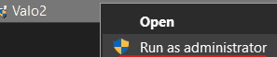
Step-2:
Paste your serial key and click "Login".
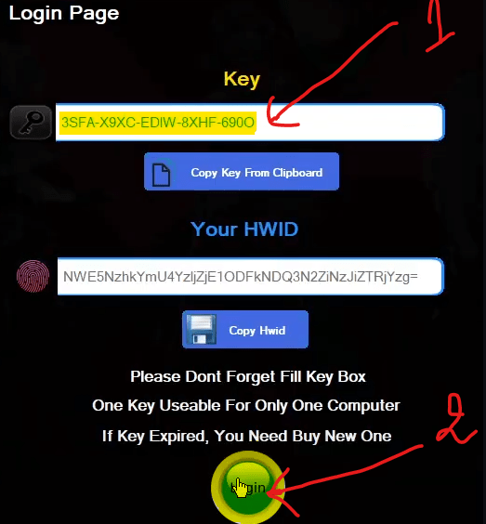
Step-3:
Once logged in you will get a confirmation message "Success"
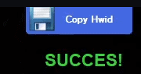

A new window will be displayed on the right side of your screen. Press the button "START"
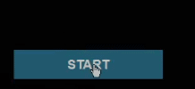
Step-4:
The injection will begin, and once you get the "waiting for game..." message. Open Game.
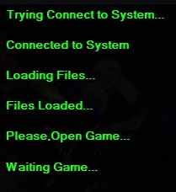
Note: The game must be running in windowed fullscreen mode!
Step-5:
The loader should detect the game process and it will ask you to press F9 key once you are in the game lobby.
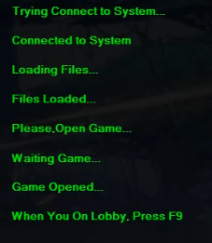
Special Note = if u get crash when u press f9 in game lobby then make sure written in below
make game windowed mode
turn off discord overlay
disabled dx12
Step-6: Open the game in WINDOWED MODE and once you reach the game lobby (where your character is shown) press the button F9 to inject the cheat to the game and wait a few seconds. If everything worked as intended you should be able to see the menu on the left side of the screen. Operate with it by pressing the button HOME from your keyboard to open/close it and using the directional arrows (UP, DOWN, LEFT, RIGHT) to enable/disable the options.
